AI-Driven Legal Information and Assistance System
A PROJECT REPORT

Submitted by
POTHUGUNTA MANEESH [RA2211032010040]
PURANAM HEMANTH [RA2211032010041]

Under the Guidance of

Dr. Praveena Akki
Assistant Professor, Networking and Communications

in partial fulfillment of the requirements for the degree of

BACHELOR OF TECHNOLOGY

in

COMPUTER SCIENCE ENGINEERING

with specialization in INTERNET OF THINGS



DEPARTMENT OF NETWORKING AND COMMUNICATION

SCHOOL OF COMPUTING

COLLEGE OF ENGINEERING AND TECHNOLOGY
SRM INSTITUTE OF SCIENCE AND TECHNOLOGY

KATTANKULATHUR- 603 203

APRIL 2025


Department of Networking and Communications

SRM Institute of Science & Technology

Own Work* Declaration Form

Degree/ Course : B.Tech, Project

Student Name : Pothugunta Maneesh, Puranam Hemanth

Registration Number : RA221102010040, RA2211032010041

Title of Work : AI-Driven Legal Information and Assistance System

We hereby certify that this assessment compiles with the University’s Rules and Regulations relating to Academic misconduct and plagiarism, as listed in the University Website, Regulations, and the Education Committee guidelines.

We confirm that all the work contained in this assessment is my our own except where indicated, and that We have met the following conditions:

- Clearly referenced / listed all sources as appropriate
- Referenced and put in inverted commas all quoted text (from books, web, etc)
- Given the sources of all pictures, data etc. that are not my own
- Not made any use of the report(s) or essay(s) of any other student(s) either past or present
- Acknowledged in appropriate places any help that I have received from others (e.g. fellow students, technicians, statisticians, external sources)
- Compiled with any other plagiarism criteria specified in the Course handbook / University website
I understand that any false claim for this work will be penalized in accordance with the University policies and regulations.

DECLARATION:
I am aware of and understand the University’s policy on Academic misconduct and plagiarism and I certify that this assessment is my / our own work, except were indicated by referring, and that I have followed the good academic practices noted above.

NAME: MANEESH POTHUGUNTA NAME: HEMANTH
REG.NUM: RA2211032010040 REG.NUM: RA2211032010041



SRM INSTITUTE OF SCIENCE AND

TECHNOLOGY

KATTANKULATHUR – 603 203

BONAFIDE CERTIFICATE

Certified that 21CSP302L - Project report titled “AI-Driven Legal Information and Assistance System” is the Bonafide work of “POTHUGUNTA MANEESH [RA2211032010040] ,PURANAM HEMANTH [RA2211032010041]” who carried out the project work under my supervision. Certified further, that to the best of my knowledge the work reported herein does not form any other project report or dissertation on the basis of which a degree or award was conferred on an earlier occasion on this or any other candidate.

SIGNATURE SIGNATURE
Dr. M. Lakshmi
PROFESSOR &HEAD
DEPARTMENT OF NETWORKING AND COMMUNICATIONS
Dr. Praveena Akki
ASSISTANT PROFESSOR
DEPARTMENT OF NETWORKING AND COMMUNICATIONS

Examiner 1 Examiner 2
ACKNOWLEDGEMENTS
We express our humble gratitude to Dr. C. Muthamizhchelvan, Vice-Chancellor, SRM Institute of Science and Technology, for the facilities extended for the project work and his continued support.
We extend our sincere thanks to Dr. Leenus Jesu Martin M, Dean-CET, SRM Institute of Science and Technology, for his invaluable support.
We wish to thank Dr. Revathi Venkataraman, Professor and Chairperson, School of Computing, SRM Institute of Science and Technology, for her support throughout the project work.
We encompass our sincere thanks to, Dr. M. Pushpalatha, Professor and Associate Chairperson - CS, School of Computing and Dr. Lakshmi, Professor and Associate Chairperson -AI, School of Computing, SRM Institute of Science and Technology, for their invaluable support.
We are incredibly grateful to our Head of the Department, Dr. M. Lakshmi, HOD, Networking and Communications, SRM Institute of Science and Technology, for her suggestions and encouragement at all the stages of the project work.
We want to convey our thanks to our Project Coordinators, Panel Head, and Panel Members Department of Networking and Communications, SRM Institute of Science and Technology, for their inputs during the project reviews and support.
We register our immeasurable thanks to our Faculty Advisors, Dr. Praveena Akki, Department of Networking and Communications, SRM Institute of Science and Technology, for leading and helping us to complete our course.
Our inexpressible respect and thanks to our guide, Dr. Praveena Akki, Department of Networking and Communications SRM Institute of Science and Technology, for providing us with an opportunity to pursue our project under her mentorship. She provided us with the freedom and support to explore the research topics of our interest. Her passion for solving problems and making a difference in the world has always been inspiring.
We sincerely thank all the staff members of Networking and Communications, School of Computing, S.R.M Institute of Science and Technology, for their help during our project. Finally, we would like to thank our parents, family members, and friends for their unconditional love, constant support and encouragement

ABSTRACT

This web app takes advantage of a contemporary tech stack to provide legal aid via an intuitive user interface and robust backend services. Developed with Next.js, the app enjoys server-side rendering, optimized routing, and other performance-improving features. React enables a component-based design, which makes the UI reusable and flexible. TypeScript introduces type safety, making the code more maintainable and less error-prone. On the server-side, Firebase is used to handle user authentication, data storage (such as legal data), and possibly file uploads or other services. Styling is achieved using Tailwind CSS, which provides a utility-first solution for a uniform, responsive look, and a UI component library, such as Shadcn UI or Radix UI, assists in speeding up development with pre-made, accessible components.

The app combines AI for two key features: a Legal Assistant and Document Clarification Tool. The Legal Assistant makes use of Natural Language Processing (NLP) and possibly a Large Language Model (LLM), allowing the app to process and answer legal questions in natural language. Likewise, the Document Clarification Tool uses document text extraction and sophisticated NLP/LLM functionality to summarize or explain lengthy legal content so that legal documents are easier for users to understand. Next.js also handles routing between various pages, such as the dashboard or the legal assistant page. The component-based structure of the app and the application of custom React hooks within the `src/hooks/` directory encapsulate logic, i.e., mobile device detection or notifications, making the app more modular and maintainable. Utility functions in `src/lib/utils.ts` facilitate general tasks throughout the app. A deeper inspection of the AI techniques, more precisely the use of the LLM and how it handles prompts, would involve looking at the code in `src/ai/` to see how the model interacts with the legal information.

TABLE OF CONTENTS

ABSTRACT iv
TABLE OF CONTENTS v
LIST OF FIGURES vii
LIST OF TABLES ix
ABBREVIATIONS x

CHAPTER NO. TITLE PAGE NO.

1 INTRODUCTION 1

1.1 Introduction to Project 1
1.2 Motivation 2
1.3 Sustainable Development Goal of the Project 2 1.4 Product Vision Statement 3
1.5 Product Goal 3
1.6 Product Backlog (Key User Stories with Desired Outcomes) 4
1.7 Product Release Plan 5

2 SPRINT PLANNING AND EXECUTION
2.1 Sprint 1 6 2.1.1 Sprint Goal with User Stories of Sprint 1 7
2.1.2 Functional Document 8
2.1.3 Architecture Document 11
2.1.4 UI Design 12
2.1.5 Functional Test Cases 13
2.1.6 Daily Call Progress 14
2.1.7 Committed vs Completed User Stories 15
2.1.8 Sprint Retrospective 17
2.2 Sprint 2 18
2.2.1 Sprint Goal with User Stories of Sprint 2 18
2.2.2 Functional Document 19
2.2.3 Architecture Document 20
2.2.4 UI Design 22
2.2.5 Functional Test Cases 24
2.2.6 Daily Call Progress 25
2.2.7 Committed vs Completed User Stories 25
2.2.8 Sprint Retrospective 27
3. RESULTS AND DISCUSSIONS 28
3.1 Project Outcomes (Justification of outcomes and how they align 29
with the goals)
3.2 Committed vs Completed User Stories 29
4 CONCLUSIONS & FUTURE ENHANCEMENT 30
APPENDIX
A. SAMPLE CODING 31
B. PLAGIARISM REPORT 35

LIST OF FIGURES

CHAPTER NO TITLE PAGE NO.
1.1 | MS Planner Board
1.2 | MS Planner Grid View | 04
1.3 | Release Plan for | 05
2.1 | User Story for User Account Management | 06
2.2 | User Story for Location Sharing and Tracking | 07
2.3 | User Story for Offline Emergency Functionality | 08
2.4 | User Story for Emergency SOS Activation | 09
2.5 | User Story for Shake to Alert Feature | 10
2.6 | User Story for Keyword based SOS | 11
2.7 | User Story for Bluetooth Based P2P Connection | 13
2.8 | System Architecture Diagram | 14
2.9 | Landing Page | 15
2.10 | Register Page | 16
2.11 | Login Page | 17
2.12 | Profile Page | 18
2.13 | Bluetooth Functionality | 19
2.14 | Home Page | 20
2.15 | Stand Up Meeting for Sprint 1 | 21
2.16 | Bar Graph for Committed Vs Completed User Stories for Sprint 1 | 22
2.17 | User Story for Emergency Support Access | 23
2.18 | User Story for Trusted Contacts Management | 23
2.19 | User Story for Hidden Camera Detection | 23
2.20 | User Story for Risk Zone Analysis | 24
2.21 | User Story for Period Tracker | 24
2.22 | User Story for Mental Health Chatbot | 24
2.23 | User Story for Community Forum | 25
2.24 | Flow Chart for the app | 26
2.25 | ER Diagram for the app | 26
2.26 | Emergency Support Access Page | 27
2.27 | Trusted Contacts Management Page | 27
2.28 | Chat Page | 28
2.29 | Community Forum Page | 28

LIST OF TABLES

CHAPTER NO TITLE PAGE NO.
1.1 | Product Backlog | 05
2.1 | Detailed User Stories for Sprint 1 | 07
2.2 | Business Processes for Sprint 1 | 10
2.3 | Access Level Authorization Matrix for Sprint1 | 12
2.4 | Detailed Functional Test Case of Sprint 1 | 14
2.5 | Sprint Retrospective of Sprint 1 | 15
2.6 | Detailed User Stories for Sprint 2 | 18
2.7 | Business Processes for Sprint 2 | 22
2.8 | Access Level Authorization Matrix for Sprint2 | 24
2.9 | Detailed Functional Test Case of Sprint 2 | 25
2.10 | Sprint Retrospective of Sprint 2 | 27

ABBREVIATION

Abbreviation | Full Form
API | Application Programming interface
GPS | Global Positioning System
SOS | Save our souls
UI | User interface
UX | User Experience
ML | Machine Learning
AI | Artificial Intelligence
QA | Quality Assurance
DB | Database
SQS | Simple Queue Service (AWS)
JSON | JavaScript Object Notation
SDK | Software Development Kit
CRUD | Create, Read, Update, Delete
I18N | Internationalization
L10N | Localization
NLP | Natural Language Processing
PWA | Progressive Web App
CI/CD | Continuous Integration / Continuous Deployment
CSV | Comma-Separated Values
OTP | One-Time Password
UAT | User Acceptance Testing
BLE | Bluetooth Low Energy
JSON | JavaScript Object Notation
UI/UX | User Interface / User Experience

CHAPTER 1
INTRODUCTION
In today's increasingly digital world, access to reliable legal information is essential for empowering individuals to make informed decisions. However, navigating complex legal systems and understanding legal documents can be challenging without specialized knowledge.
1.1 Introduction
To address this gap, "Legal Advisory" has been developed as an AI-powered web application that simplifies access to legal information, document clarification, and advisory support.
Built using modern technologies like Next.js, React, TypeScript, and Firebase, and powered by advanced AI models for natural language understanding, Legal Advisory offers users a platform where they can: Ask legal questions right away with an AI-powered legal assistant,
Upload and use AI analysis to make sense of complicated legal documents. Examine a collection of carefully chosen legal information from several fields.

This project adopts a component-driven design with a responsive UI crafted with Tailwind CSS and Shadcn UI components, ensuring a seamless, accessible, and scalable user experience. Legal Advisory bridges the gap between individuals and complex legal information, making the law more approachable, understandable, and actionable.

1.2 Motivation
Legal literacy remains a significant barrier for many individuals seeking justice or simply understanding their rights. Traditional legal resources are often complex, inaccessible, or expensive. Furthermore, with the exponential growth of documentation in legal processes, individuals frequently struggle to comprehend and act upon legal papers effectively.
Motivated by the need to democratize legal information and empower individuals with AI-driven tools, Legal Advisory focuses on providing: Instant, accurate legal query resolution,
Simplified understanding of dense legal documents, Organized access to categorized legal knowledge. The platform is intended for citizens navigating legal frameworks in both their personal and professional lives, in addition to professionals and students.

1.3 Sustainable Development Goal of the Project
Legal Advisory aligns directly with Sustainable Development Goal(SDG) 16: "Peace, Justice and Strong Institutions". By promoting easy and equitable access to justice-related information, the platform: Enhances transparency and legal awareness, empowers individuals to understand their rights, supports efforts towards building accountable and inclusive societies. Through technology, Legal Advisory contributes to a more just and informed global community.

1.4 Product Vision Statement

1.4.1. Audience

Primary Audience:

The public looking for prompt legal advice.

Students and those studying law.

Startups and small enterprises require a basic understanding of the law.

Secondary Audience:

To incorporate AI into initial client support, law firms and advisory services.

community-based legal aid organizations.

educational establishments that provide legal education.

1.4.2. Needs

Primary Needs:

trustworthy AI-based responses to frequently asked legal queries.

clarification and synopsis of the legal documents that were uploaded.

A searchable database of categorized legal data.

Secondary Needs:

User profiles and secure authentication.

scalable backend to manage uploads and AI queries

user interface that is accessible and responsive on all devices.

1.4.3. Products

Core Product:

A web application built using Next.js and Firebase.

AI assistant for legal questions.

uploading documents and an AI system for clarification.

domain-based information repository (e.g., Criminal Law, Consumer Rights).

Additional Features:

Shadcn UI and Tailwind CSS are used in responsive UI/UX design.

Firebase Authentication for managing users

toast alerts and optimizations for mobile devices.

future scalability through integrations with third-party AI APIs.

1.4.4. Values

Core Values:

Providing everyone with access to legal information is known as accessibility.

Clarity: Using AI to make complex legal terminology simpler.

Empowerment: Giving people the means to make better decisions.

Differentiators:

Clarification of documents using AI (not just static document upload).

categorized legal archive for independent study.

A cutting-edge, user-friendly interface with ongoing improvement.
1.5 Product Goal
Through the accomplishment of this objective, the platform hopes to promote greater legal empowerment, lessen reliance on pricey consultations for basic legal assistance, and streamline access to legal knowledge.

1.6 Product Backlog
Table 1.1 Product Backlog
S. No | User Stories of LEGAL ADVISORY
#US1 | As a user, I want secure sign-up and login functionality.
#US2 | As a user, I want a mobile-responsive and accessible user experience.
#US3 | As a user, I would like to pose legal queries and receive AI-powered answers.
#US4 | I want to be able to upload legal documents and get clearer explanations as a user.
#US5 | I want to browse categorized legal information topics as a user.
#US6 | I want to keep an eye on document uploads and AI query flow as an administrator.

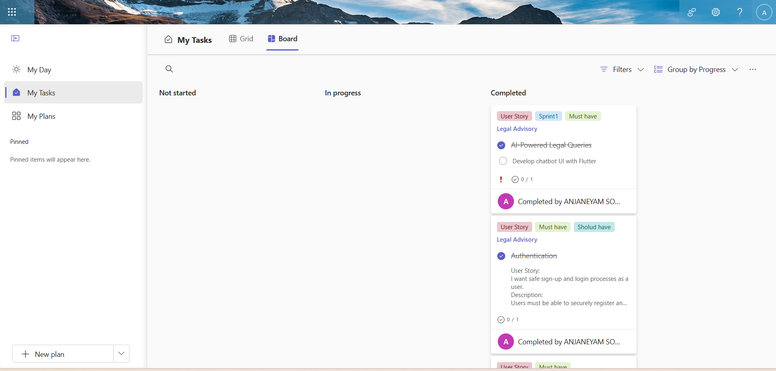
Figure 1.1 MS Planner Board
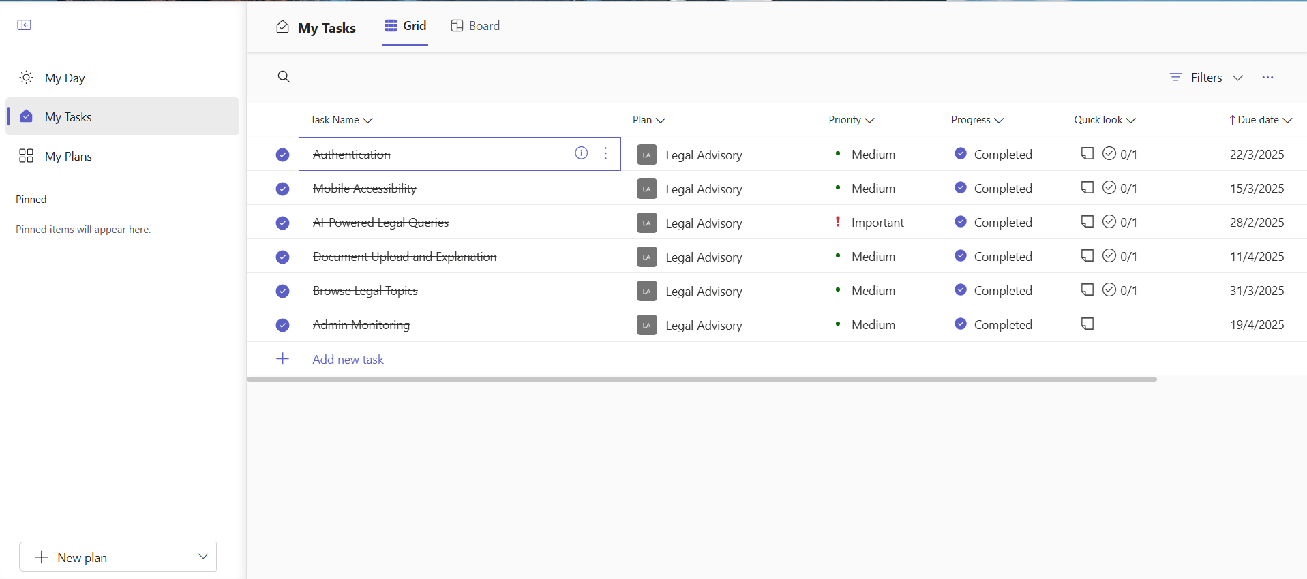
Figure 1.2 MS Planner Grid View

1.7 Product Release Plan
The following Figure 1.3depicts the release plan of the project
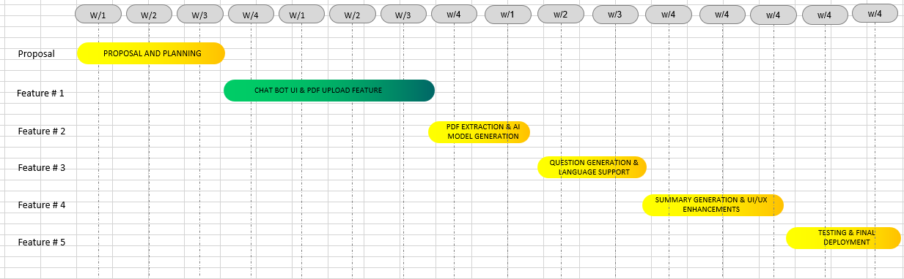
Figure 1.3 Release plan

CHAPTER 2
SPRINT PLANNING AND EXECUTION
2.1 Sprint 1
2.1.1 Sprint Goal with User Stories of Sprint 1
Set up secure user authentication.
Ensure a fully responsive, mobile-friendly user experience.
Enable AI-based legal question answering.
Table 2.1 Detailed User Stories of sprint 1
S.NO | Detailed User Stories
#US1 | As a user, I want secure sign-up and login functionality.
#US2 | As a user, I want a mobile-responsive and accessible user experience.
#US3 | As a user, I would like to pose legal queries and receive AI-powered answers.

Planner Board representation of user stories are mentioned below figures 2,1,2.2 and 2.3.
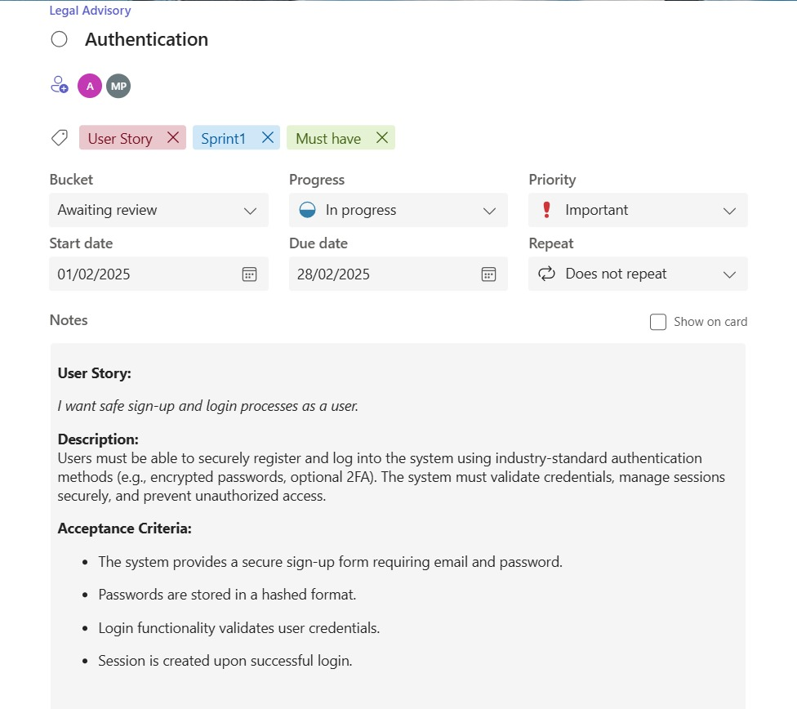Figure 2.1 User Story 1
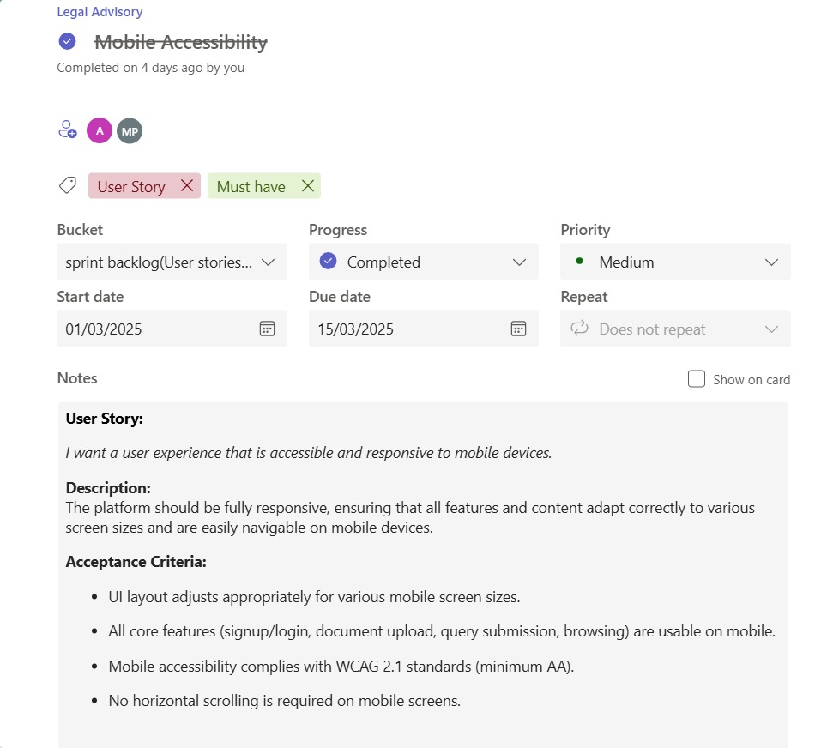
Figure 2.1 User Story 2

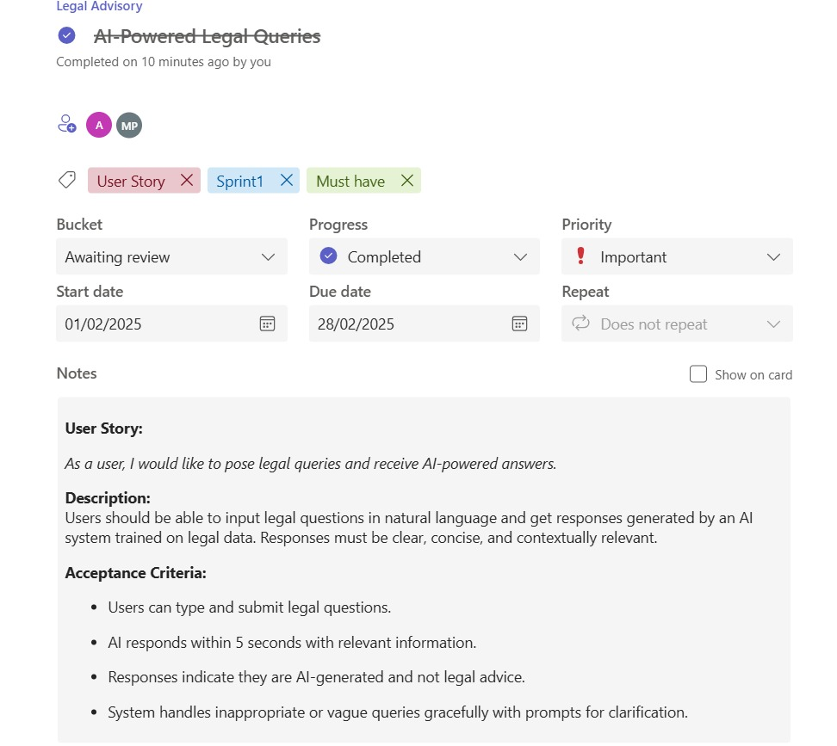 Figure 2.3 User Story 3

2.1.2 Functional Document

2.1.2.1 Introduction
Sprint 1's goals are to create a safe user authentication system, make sure the design is completely responsive to mobile devices, and deploy an AI-powered legal assistant that can efficiently respond to user inquiries.

2.1.2.2. Product Goal

Make it possible for users to sign up, log in, and use the platform safely.
Provide a smooth user experience on desktops and mobile devices.
Answer user-submitted legal queries with AI-generated answers.

2.1.2.3. Demography (Users, Location)

Users: The general public, law students, entrepreneurs, and anybody else in need of basic legal support.

Location: primarily aimed at Indian users, with plans to expand internationally in subsequent iterations.

2.1.2.4. Business Processes
Table 2.2 Business Processes of Sprint 1
Process | Description
User Registration/Login | Enrollment and Login of UsersFirebase Auth allows users to safely register and authenticate.
Access That Responds to Mobile | Every page changes dynamically on desktop, tablet, and mobile devices.
Interaction with a Legal Assistant | Through a chat interface, users can ask questions and get AI-generated answers.

2.1.2.5. Features

Feature 1: User Account Management
Description: With Firebase Authentication, users can create accounts using their email address and password.
User Story: features for safe password resets, logouts, and logins.

Feature 2: User Interface That Responds to Mobile Devices

Description: Every page (Login, Signup, Home, and Legal Assistant) adapts to the size of the device.

User Story: TailwindCSS is used to create layouts that are flexible and fluid.

Feature 3: Legal Assistant Driven by AI

Description: Users can enter legal questions in a chat window.

User Story: After processing inquiries, the system provides a simplified legal explanation produced by AI.
2.1.2.6. Authorization Matrix
Table 2.3 Access level Authorization Matrix of Sprint 1
Role | Access Level
Registered User | A registered user can browse platform features and access Legal Assistant.
Guest | Guest access is restricted; in order to access core services, one must register or log in.

2.1.2.7. Assumptions
Services for Firebase authentication will be accessible and properly set up.
Initially, a simple prompt system will be used to handle AI model responses; this system can be expanded in the future.
Users are expected to have stable internet access for real-time chat functionality.
2.1.3.Architecture Document
2.1.3.1. Application
The modular architecture of the Legal Advisory platform is based on Next.js and Firebase and is inspired by microservices, guaranteeing high scalability, real-time responsiveness, and maintainability. The following essential architectural elements make up the solution:
Frontend Layer: TailwindCSS and Next.js (a React-based framework) were used to create responsive, component-driven, and search engine optimization-optimized web pages.
Backend Layer: Controlled by serverless AI API integration (for document analysis and legal query).
Data Storage Layer: AI queries are processed instantly without requiring long-term storage for confidentiality, while Firebase controls authentication states.
AI Communication Layer: To handle user inquiries and document uploads, the web application establishes RESTful API connections with external AI engines.

2.1.3.2 System Architecture
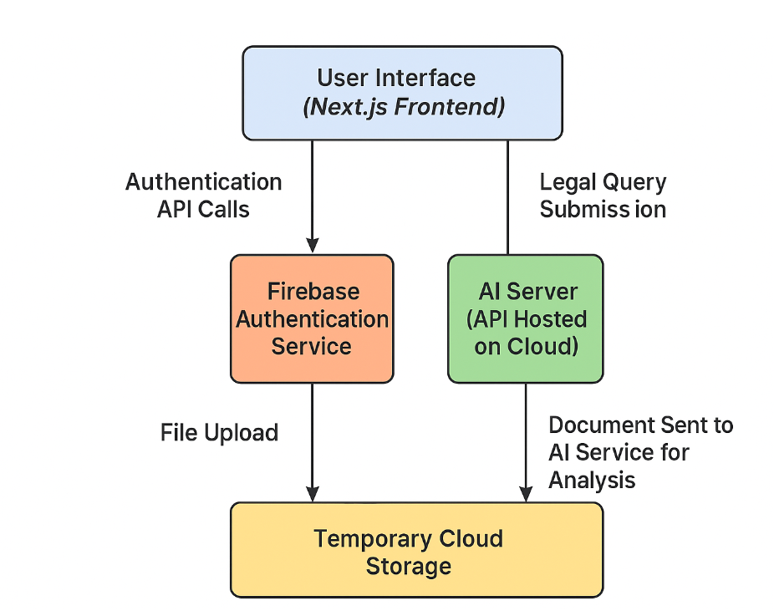
2.1.3.3. Data Exchange Contract
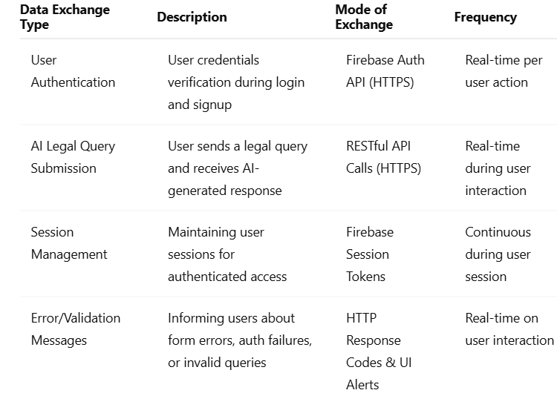

2.1.4 UI Design
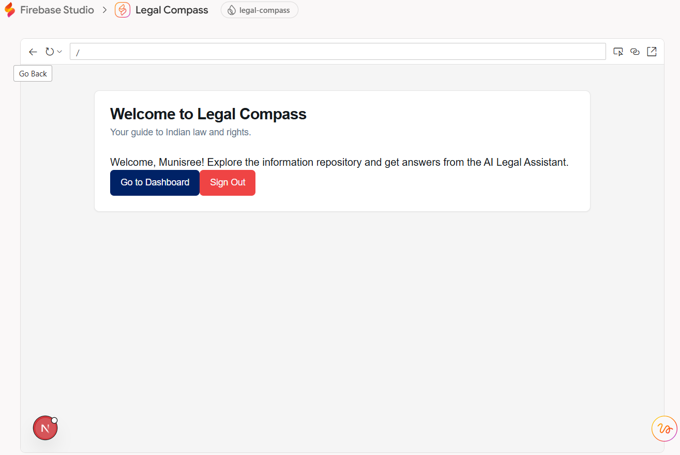Figure 2.5 Landing Page
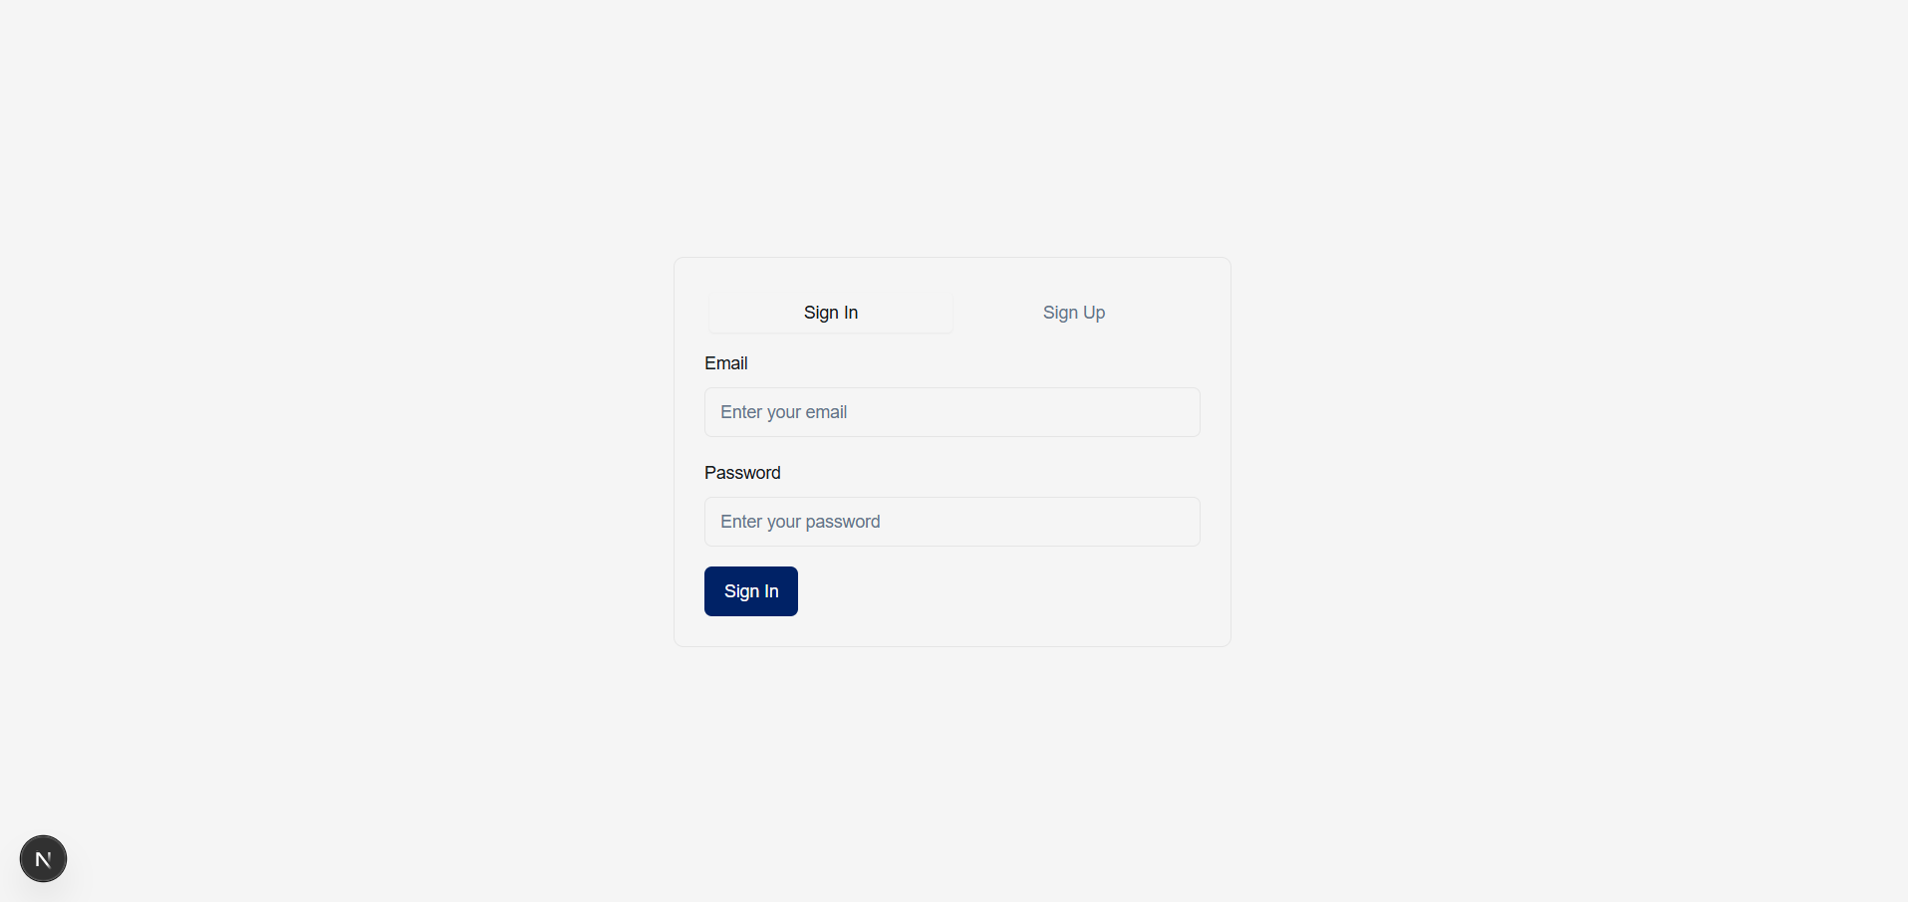
Fi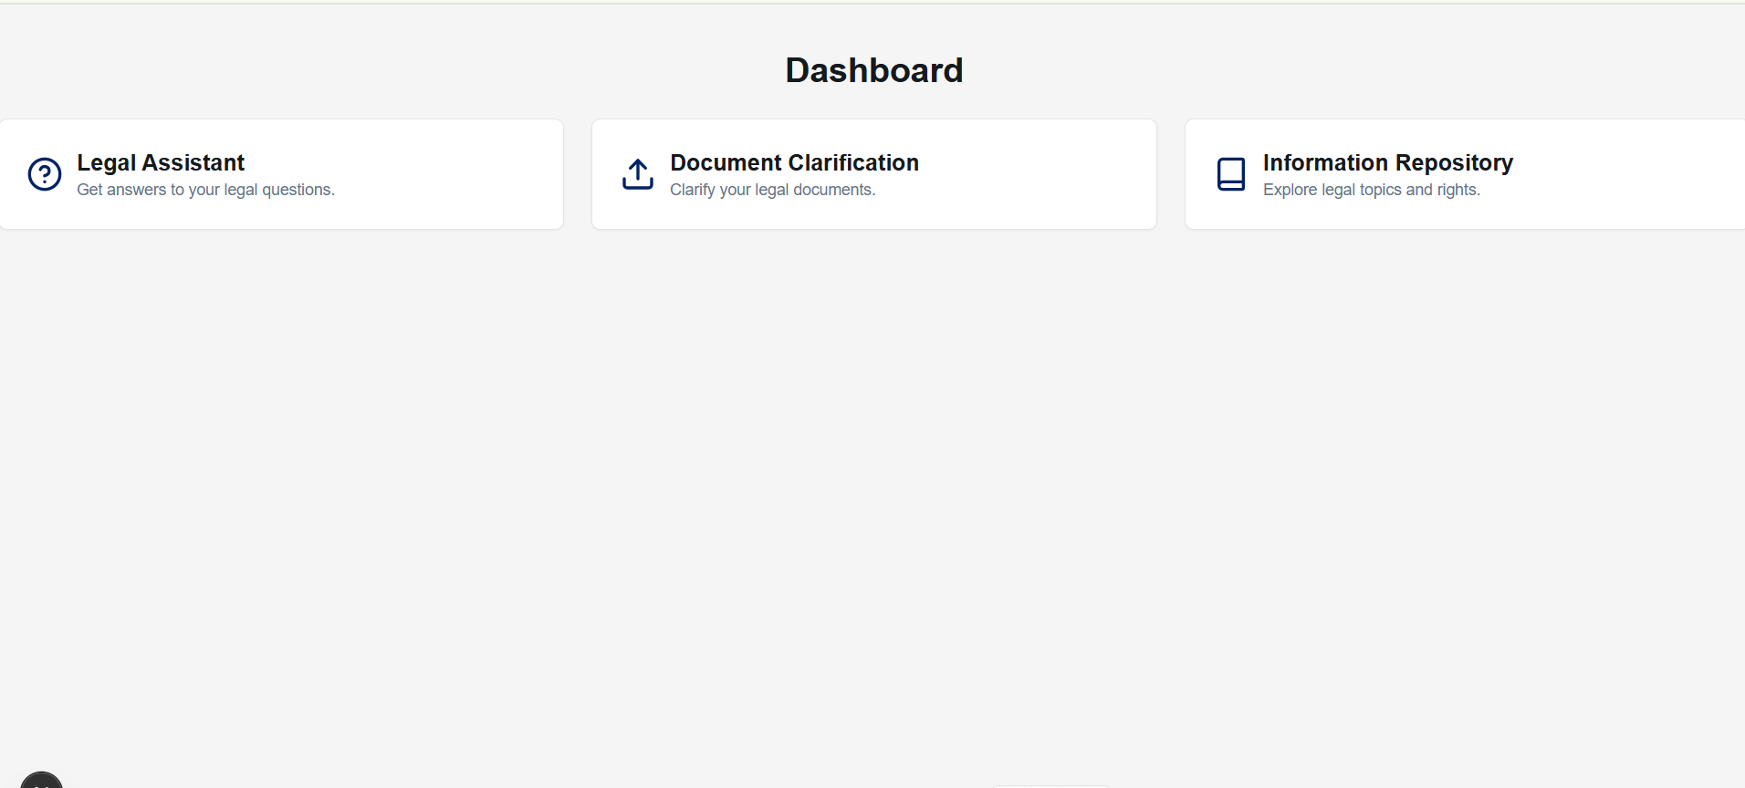Figure 2.6 Login Page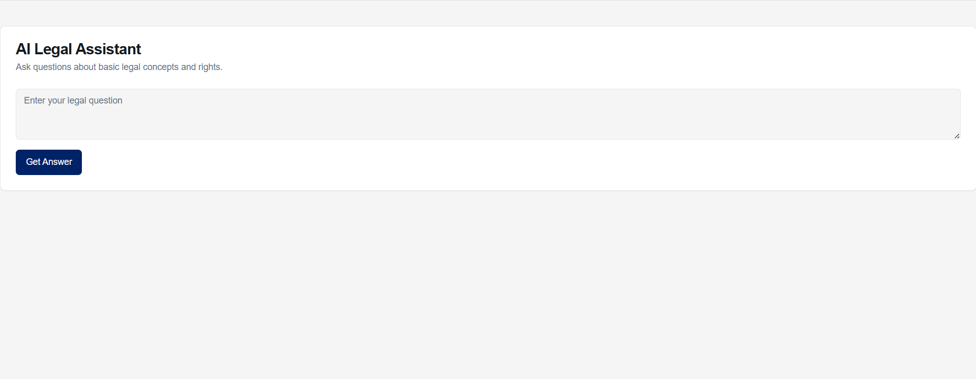Figure 2.10 ChatBot Page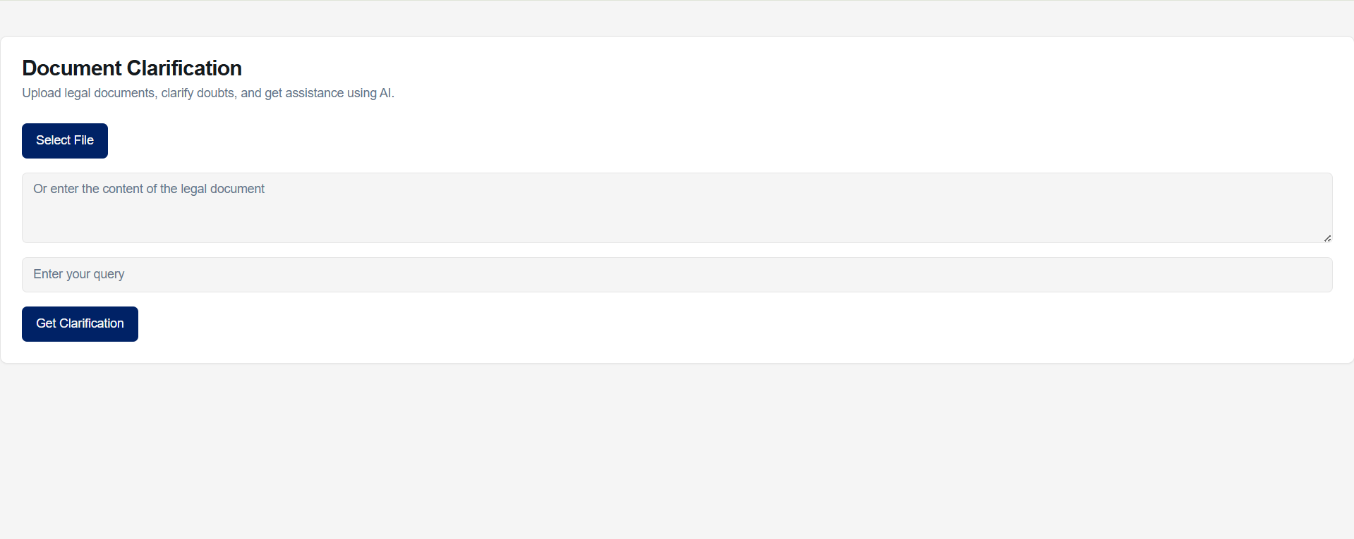Figure 2.11 Document Clarification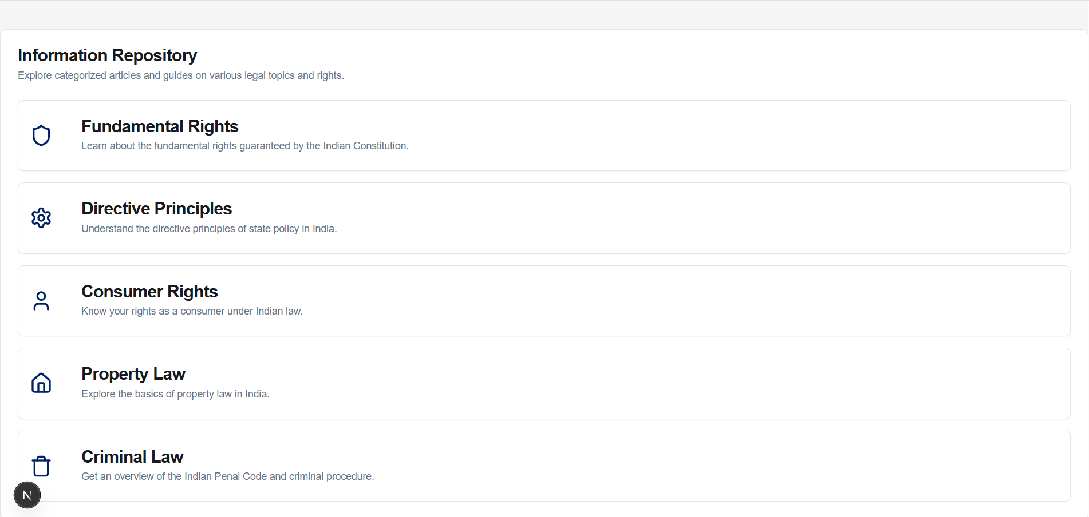Figure 2.12 Inforation Repository

2.1.5 Functional Test Cases
Table 2.4 Detailed Functional Test Case of Sprint 1
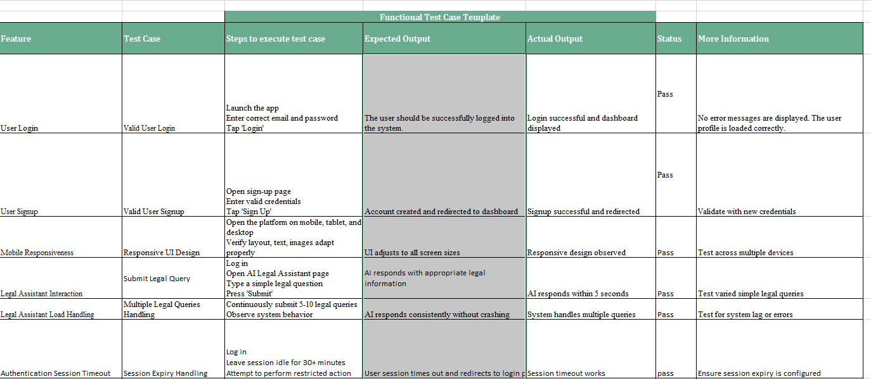
2.1.6. Daily Call Progress
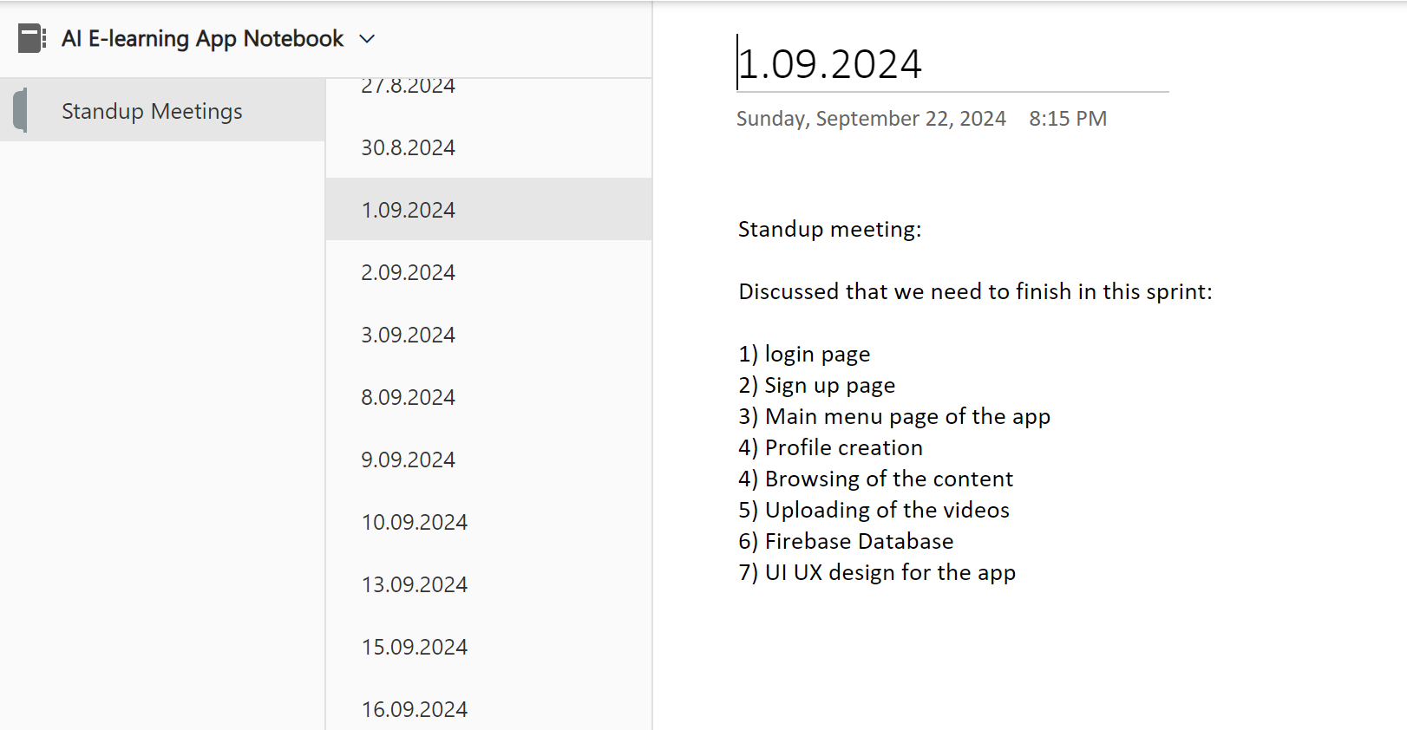
Figure 2.15 Standup meetings of Sprint 1

2.1.7 Commited Vs Completed User Stories
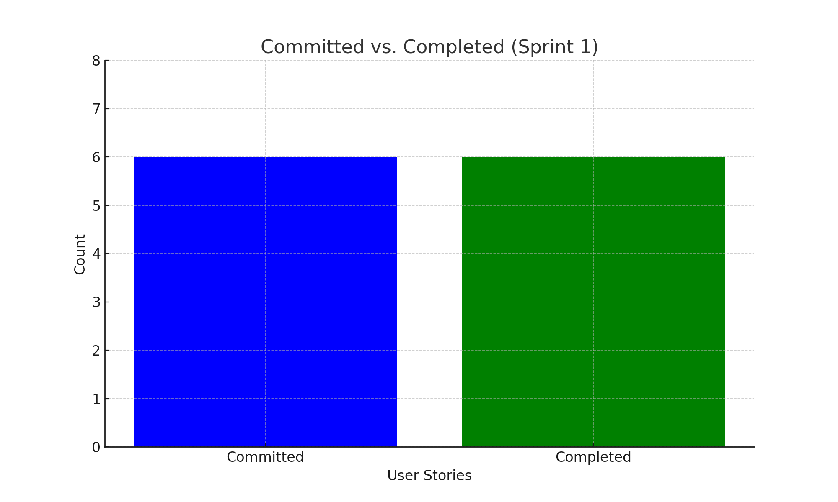

Figure 2.16 Bar graph for Committed Vs Completed User Stories for sprint 1
2.1.8 Sprint Retrospective
Table 2.5 Sprint Retrospective for sprint 1
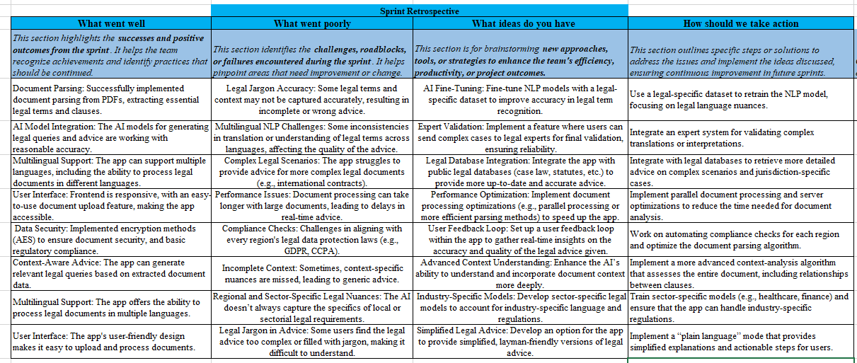
2.2 SPRINT 2
2.2.1 Sprint Goal with User Stories of Sprint 2
Turn on the upload and clarification features for documents.
Create and incorporate a repository of categorized legal information.
Use the admin dashboard to keep an eye on activities.

The following table 2.6 represents the detailed user stories of the sprint 2
Table 2.6 Detailed User Stories of sprint 2
S.NO | Detailed User Stories
#US4 | I want to be able to upload legal documents and get clearer explanations as a user.
#US5 | I want to browse categorized legal information topics as a user.
#US6 | As a user, I would like to pose legal queries and receive AI-powered answers.
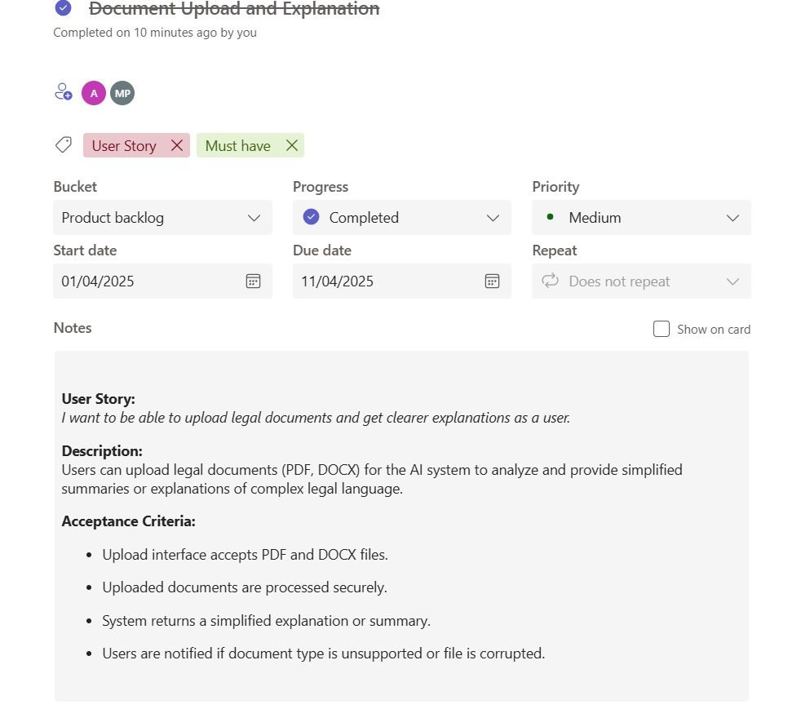
Figure 2.4 User story 4

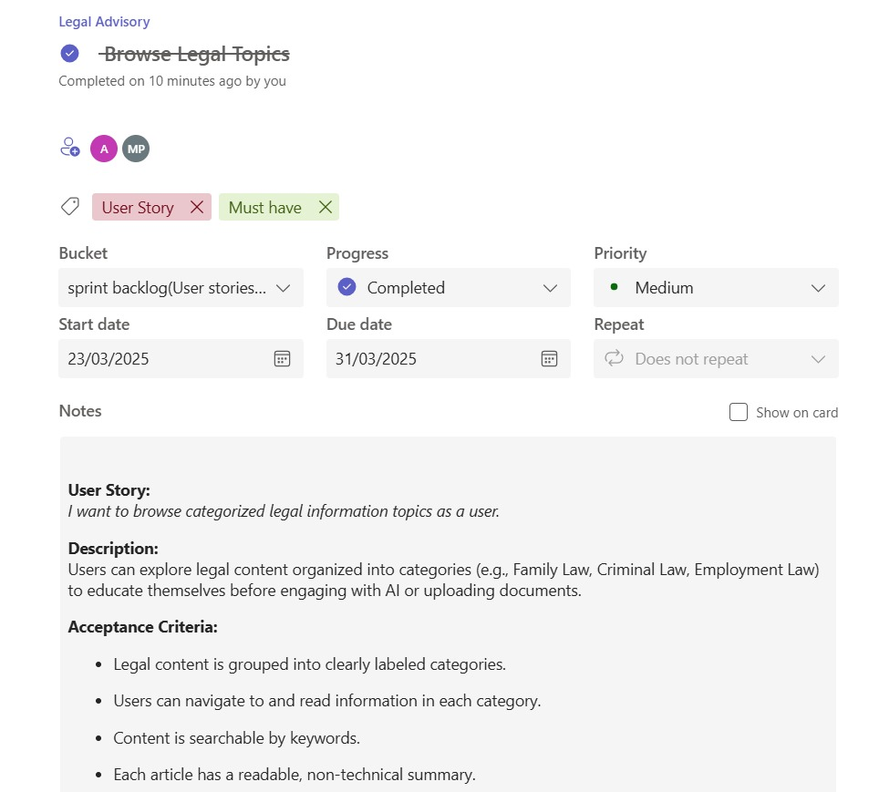
Figure 2.5 User story 5
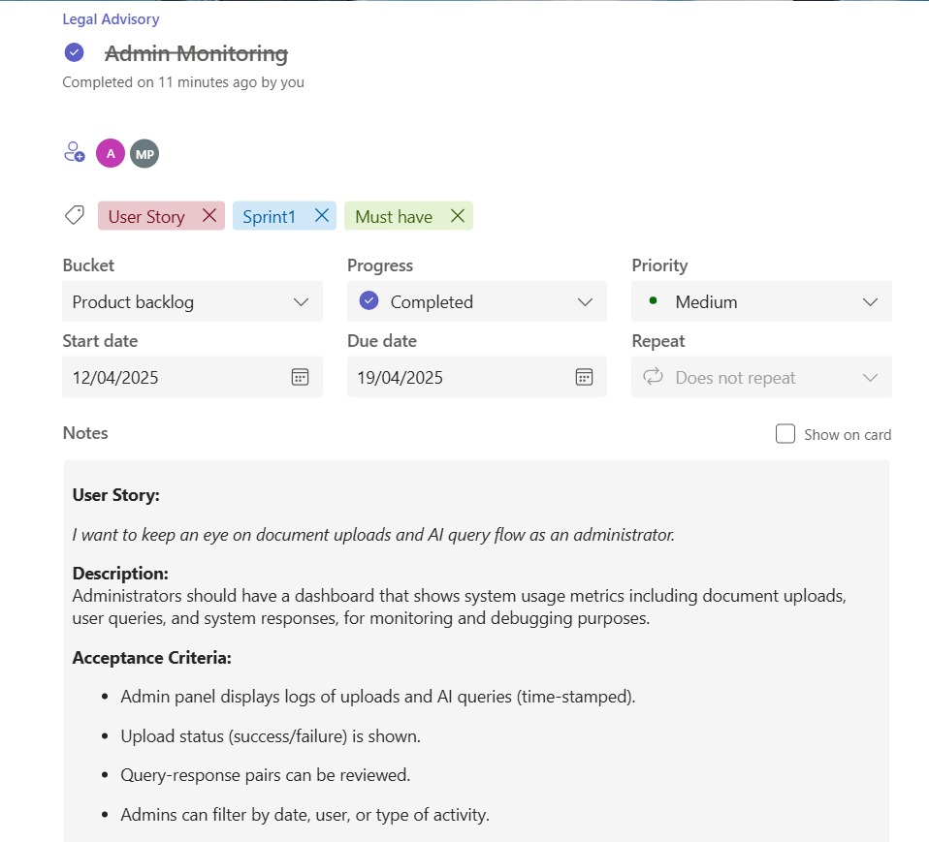
Figure 2.6 User story 6
2.2.2 Functional Document
2.2.2.1 Introduction
Sprint 2 aims to give administrators a view to track platform usage, enable users to upload legal documents for AI clarification, and give users access to a structured repository of legal topics.
2.2.2.2 Product Goal
Give users the option to submit legal documents for streamlined analysis.
Permit users to peruse legal subjects divided into different categories.
Give system usage dashboards to administrators.
2.2.2.3 Demography (Users, Location)
Users:
Legal advisors, small business owners, law students, and general users

Location:
India (primary), with plans for worldwide access
2.2.2.4 Business Processes
Table 2.7 Business Processes for sprint 2
Process | Description
Uploading Documents and Providing Clarification | AI analyzes documents uploaded by users and provides condensed explanations.
Examine the Legal Repository | For self-education, users peruse categorized topics.
Administrator Monitoring | Admins examine statistics on user interactions, AI usage, and uploaded documents.

2.2.2.5 Features
Feature 1: Get AI-powered clarification by uploading legal documents.
Description: Give users the option to upload PDF or DOCX files and get AI-powered, simplified explanations.
User Story: I want to be able to upload legal documents and get clearer explanations as a user.
Feature 2: Search the legal database by categories such as criminal law, consumer rights, etc.
Description: Give users the ability to browse a categorized library of legal subjects, including criminal law and consumer rights.
User Story: I want to browse categorized legal information topics as a user.
Feature 3: Admin Dashboard for query, upload, and usage tracking.
Description: Give admin users access to system usage statistics, such as the quantity of uploads and queries made.
User Story: A As a user, I would like to pose legal queries and receive AI-powered answers.
2.2.2.6 Authorization Matrix
Table 2.8 Authorization Matrix for sprint 2
Role | Access Level
Registered user | Browse the repository and upload documents.
Admin | View statistics and access the monitoring dashboard.
Guest User | restricted ability to view public content and peruse available sessions.
2.2.2.7 Assumptions
Users upload legitimate DOCX and PDF files.
AI clarification in real time with low latency.
Periodically, the admin dashboard displays updated statistics.
2.2.3 Architecture Document
2.2.3.1 Flow Chart:
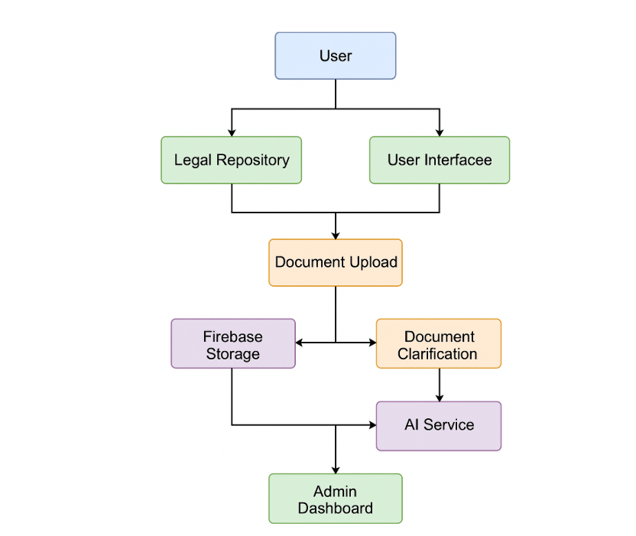
Figure 2.24 Flow Chart for the app

2.2.3.1 ER Diagram:
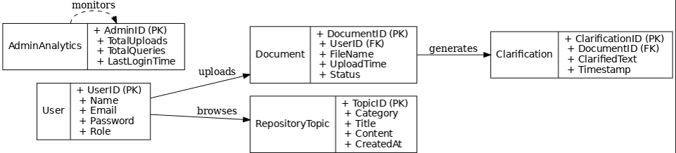
Figure 2.25 ER Diagram for the app

2.2.3.3. Data Exchange Contract
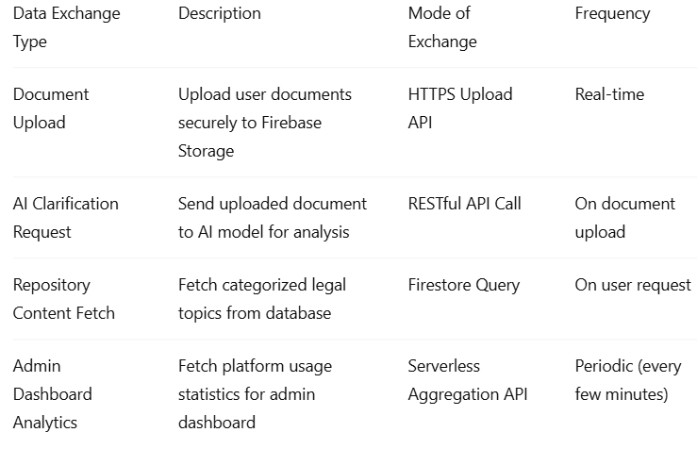

2.2.5 Functional Test Cases
Table 2.9 Deatailed Functional Test Case of Sprint 2

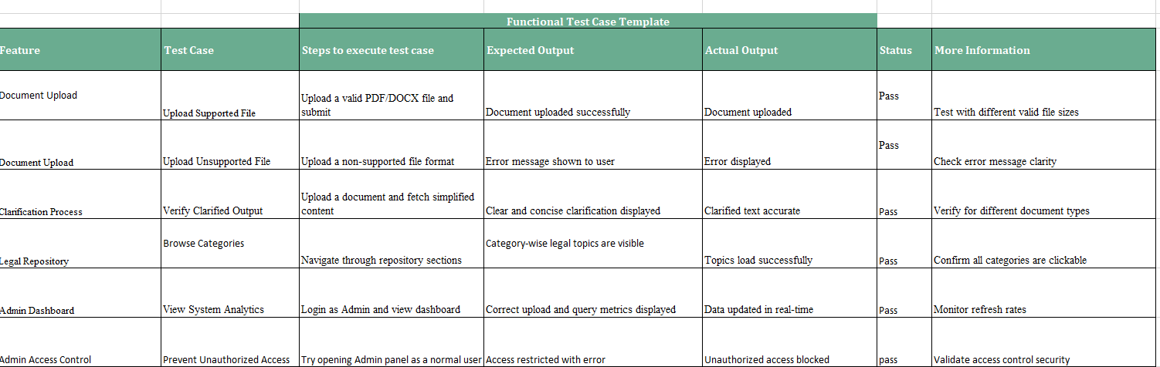
2.2.7 Commited Vs Completed User Stories
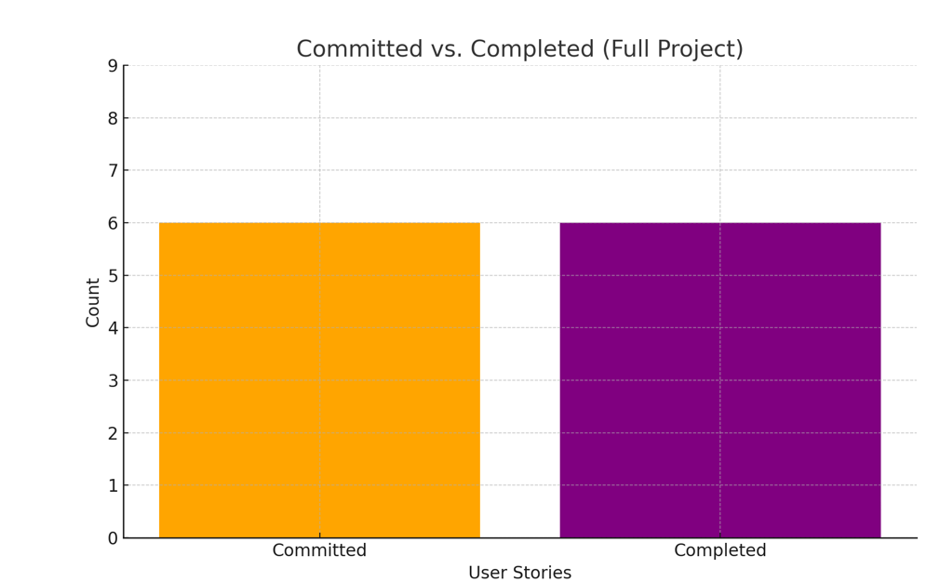
Figure 2.35 Committed Vs Completed User Stories of Sprint 2

2.2.8 Sprint Retrospective
Table 2.10 Sprint Retrospective of Sprint 2


CHAPTER 3
RESULTS AND DISCUSSION
  - Project Outcomes
Sprint 1: Foundation and Core Features
Sprint 1 focused on establishing the fundamental components required for a robust, user-centric legal platform. The main goal was to ensure users could interact securely and efficiently with the system while receiving immediate AI-assisted legal support. Key developments included:
Authentication System
Powered by Firebase Authentication, the platform ensures secure access by enabling users to register, log in, and maintain active sessions safely.
Incorporates features like password encryption, session persistence, and multi-device login, supporting a seamless and trustworthy user experience.
Responsive User Interface
Built with a mobile-first design philosophy, the UI dynamically adapts to various screen sizes—providing an optimized experience on desktops, tablets, and smartphones.
Enhances accessibility for users from different demographic and geographic regions, especially where mobile usage dominates.
AI-Powered Legal Assistant
Enables users to ask legal questions in natural language and receive concise, context-aware responses generated by AI.
Supports multi-turn conversations, making the legal assistant more interactive and human-like.
The assistant provides support for general legal queries across domains such as civil rights, labour laws, contract disputes, and more.

Sprint 2: Feature Expansion and Administrative Capabilities
Sprint 2 was aimed at enriching the platform by introducing document intelligence, structured legal resources, and administrative oversight tools to scale platform utility and manageability.
Document Upload and Clarification
Users can upload legal documents in PDF and DOCX formats, which are parsed and analysed using AI.
The platform extracts key legal information and provides simplified, layman-friendly summaries or clarifications for easier understanding.
Use cases include explaining contracts, court summons, legal notices, and more.
Categorized Legal Information Repository
A well-structured legal knowledge base has been integrated, segmented into intuitive categories such as:
Criminal Law
Consumer Protection
Family Law
Employment Law, etc.
This repository enables users to browse and self-educate on various legal topics, reducing dependency on real-time queries.
Admin Dashboard and Monitoring Tools
A dedicated admin panel gives platform administrators oversight on:
User activity and engagement
Total AI queries made
Number of documents uploaded
System performance metrics
The dashboard is interactive and can generate visual insights such as graphs and charts to track usage trends and support decision-making.
3.2 Committed Vs Completed User stories
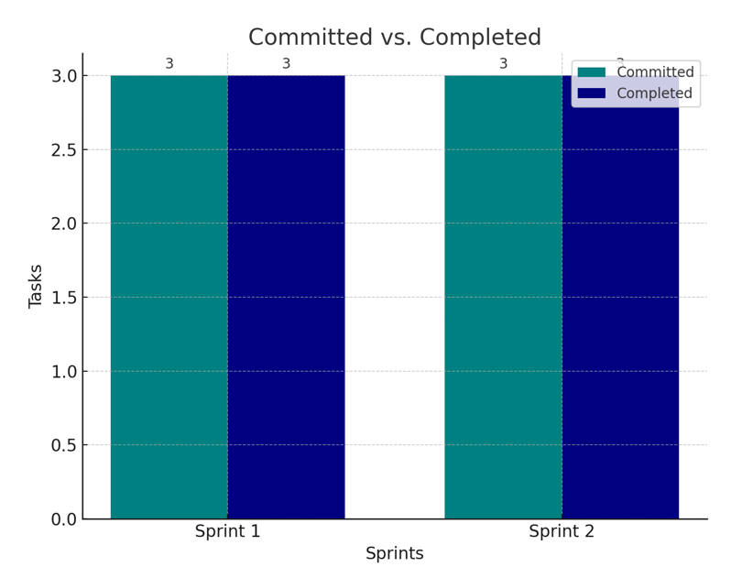
Figure 3.1 Committed Vs Completed User Stories

CHAPTER 4
CONCLUSION & FUTURE ENHANCEMENTS

Although the essential features have been successfully implemented, a number of improvements are suggested for upcoming versions to further improve the platform.
4.1 Future Enhancements

Improved AI Capabilities:

Optimize the AI models to deliver context-sensitive and even more precise legal explanations.

Include multilingual support for legal documents and inquiries.

Advanced Analytics for Administration:

For usage trends, include predictive analytics.

Present comprehensive dashboards of user activity.

Improvements to User Profiles:

Permit users to bookmark legal articles for future use, save queries, and maintain profiles.

Enhanced Repository:

Add new subjects and subcategories to the categorized legal information on a regular basis.

Enhancements in Security:

For more precise permissions, use role-based access controls (RBAC).

Encrypt documents before uploading them.

Enhancement of Performance:

Use content caching and lazy loading to speed up data retrieval.

Version of the mobile application:

Create a specialized mobile
4.2 Conclusion
Strategic sprint planning, meticulous execution, and smooth teamwork allowed the "Legal Advisory:
All committed user stories were finished in two sprints, resulting in a platform that lets users
Create an account and use Firebase Authentication to safely log in Get access to an intuitive and mobile-responsive interface, Send in legal questions to get answers produced bAI, Upload legal documents to get clarification from AI, Look through repositories of categorized legal information.
Permit administrators to keep an eye on document queries and platform usage.
Advanced technologies like Next.js, TailwindCSS, Firebase services, and RESTful API communication with AI models are all integrated into the system. The use of serverless architectures and contemporary UI frameworks improved user satisfaction, scalability, and performance.
  - SAMPLE CODING
Welcome Screen
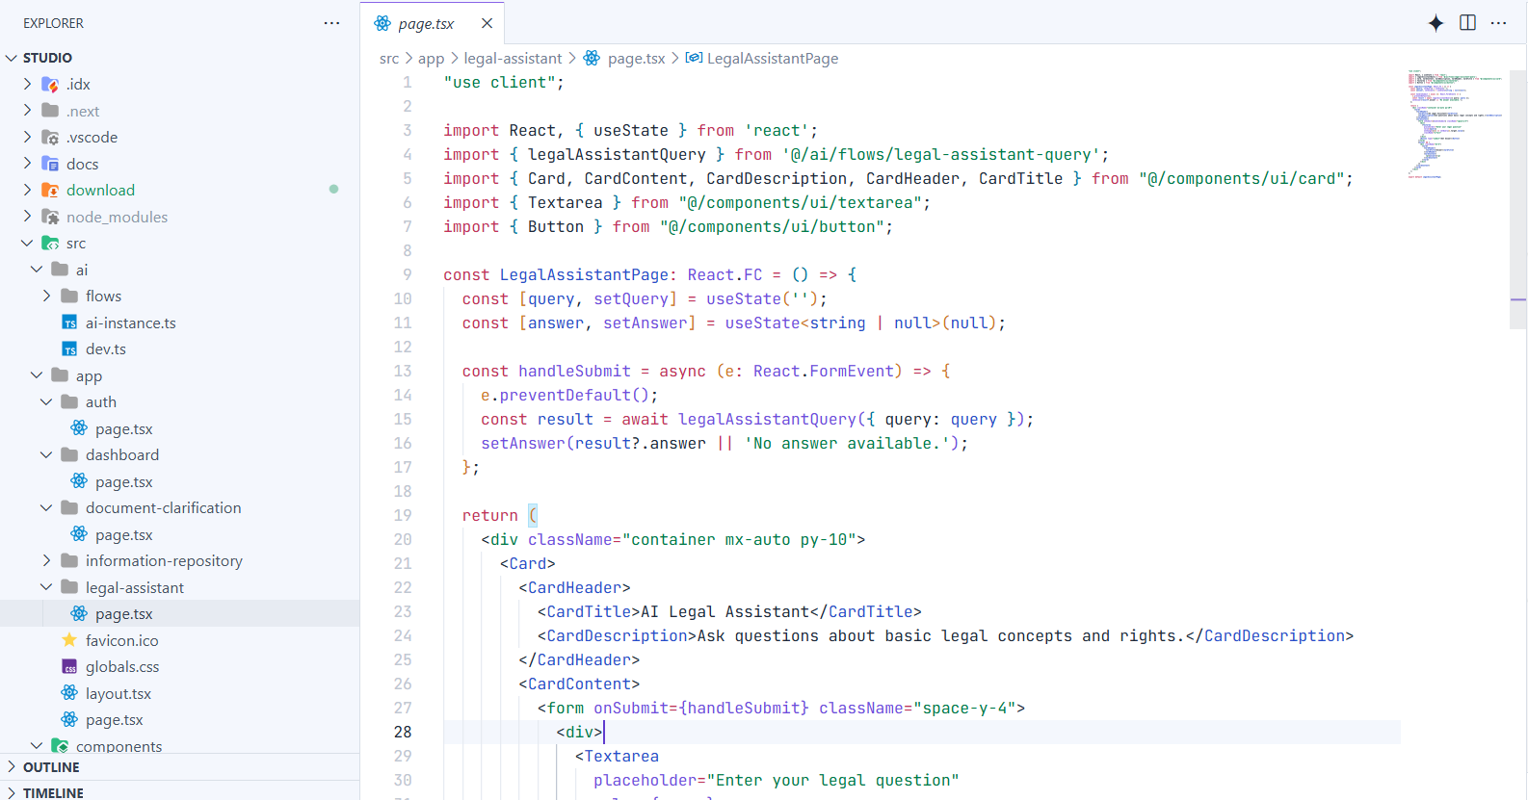
Register Screen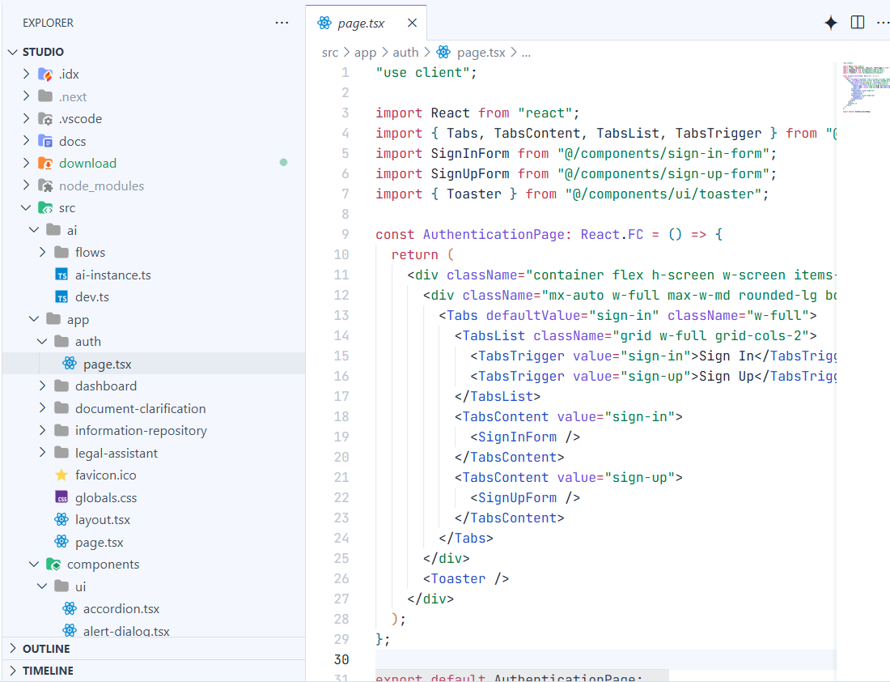
Dashboard
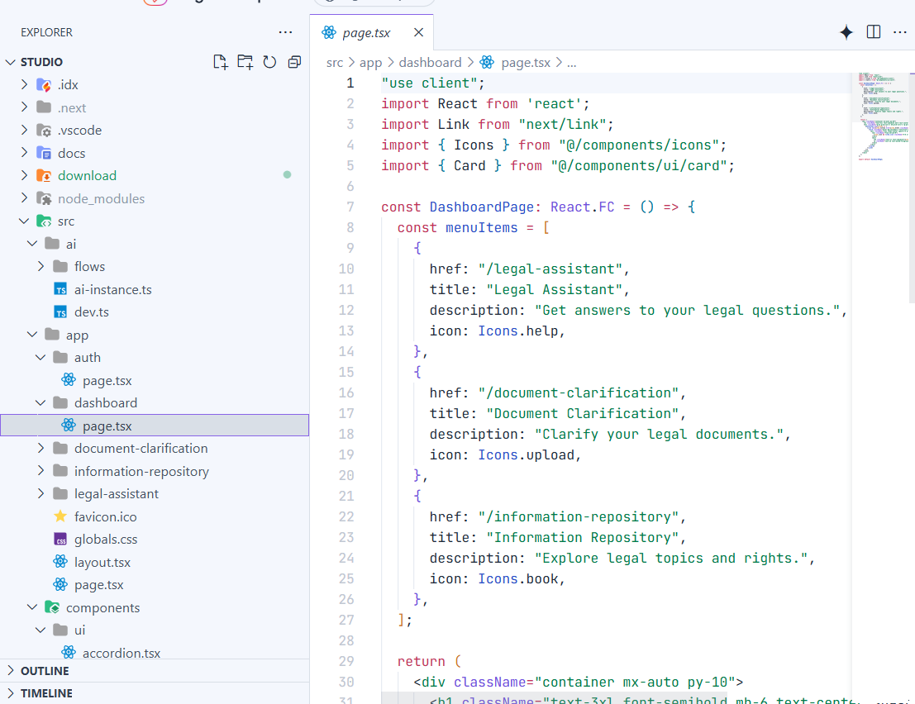

Document Clarification
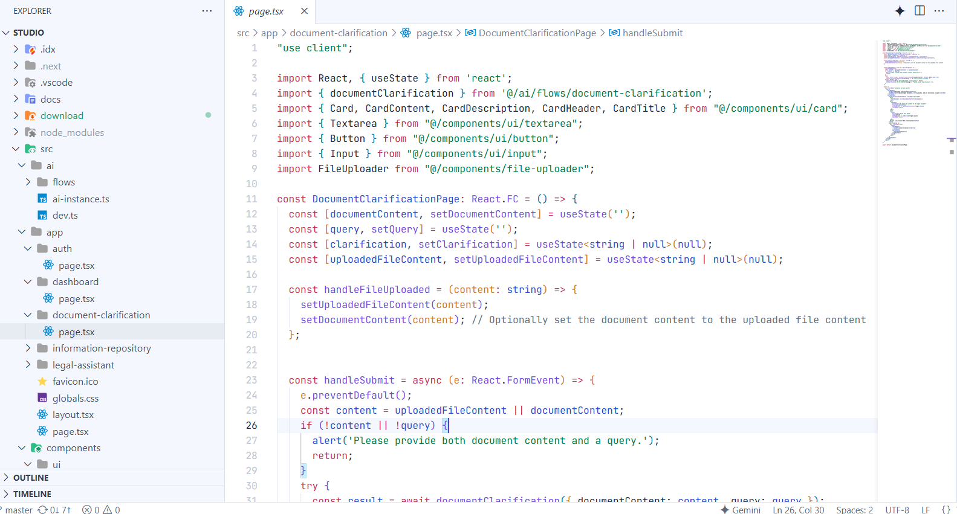

Information Repository
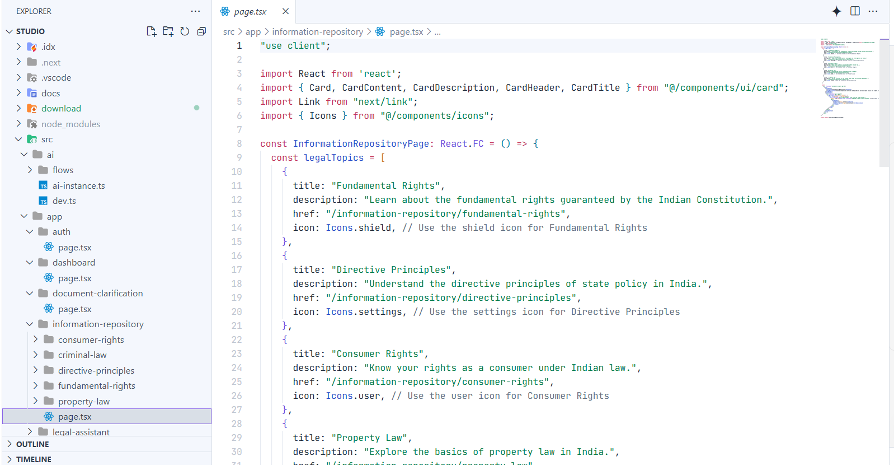

PLAGIARISM REPORT

